

**AZ Bookings**

Final year Project Proposal

Ashar Zafri  
G00366561

BEng(H) in Software & Electronic Engineering

Galway-Mayo Institute of Technology

2021/2022

# Project Description

For my final year project, I will make a booking web app for barbers. This idea came to me during Covid. When the lock down opened, barbers were only having a curtain amount of customer at a time due to restrictions. Covid created long waiting times and barber shop congestion. This Web app will allow customers to pick a time that the barber is available and avoid waiting time.

AZ Bookings is an online booking application that allows customers to choose their barbers and opening slots, based on barber availability. AZ Bookings work with an account where you can create a new one or log in with a current one. Existing accounts will be able to check personal information (name, email, phone number and gender), previous bookings, give discounts (based on the number of bookings).

On the other hand, Barbers will be able to update availability and mark successful bookings. Barber will also be able see missed appointments by customer. Moreover, Barber should be able to update prices.

To make this possible, I will be using React, HTML, and JavaScript as codebase. NoSQL database through AWS cloud to retain customer data (customer/barber accounts and schedules).

# Challenges

Challenging part of this project will be working with a database and setting up AWS. This is because I have no previous experience with databases and AWS before. I will be researching and use tutorials recommended by lectures.

# Architecture Diagram

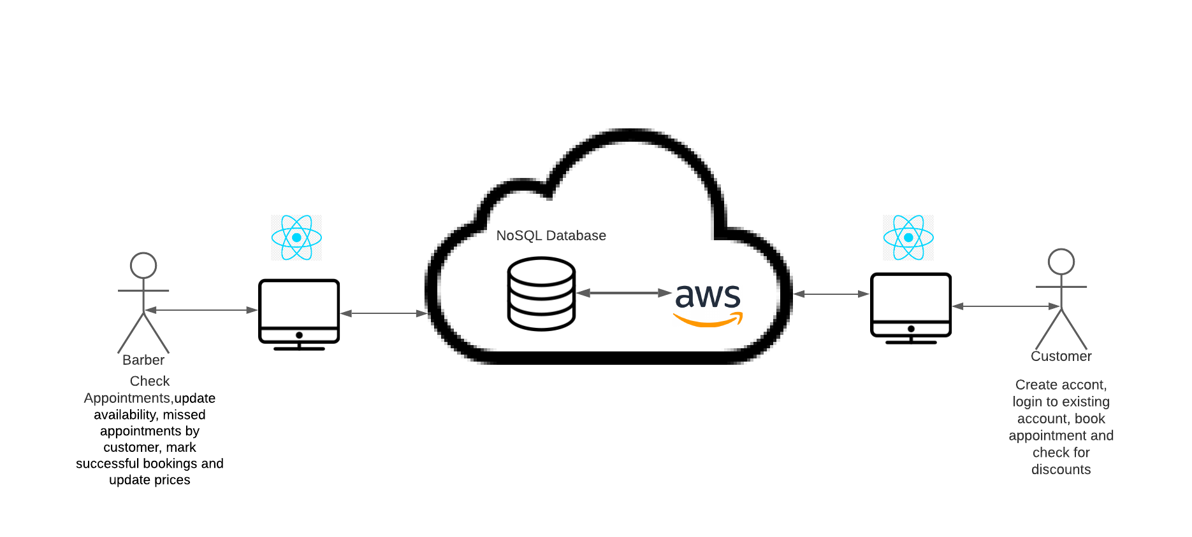

# Project Timeline

